MEMORANDUM OF UNDERSTANDING

between

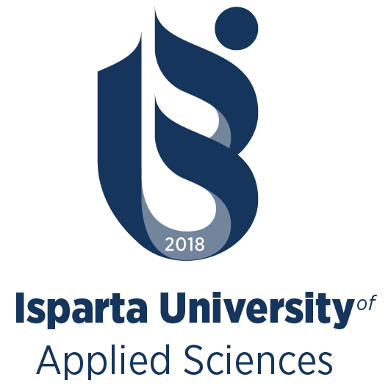

Isparta University of Applied Sciences

And

(LOGO)

Partner Institution

Isparta University of Applied Sciences (hereafter referred to as IUAS, address: 3226 Merkez, Isparta, Turkey) and …. University aim to establish and develop a strategic collaborative relationship in order to promote academic and cultural exchange between the two institutions based on the following provisions:

Areas of Cooperation

The Cooperation Protocol will serve as a general framework for institutional cooperation through a broad range of activities such as:
  - Exchange of students for study and research;
  - Short-term programs;
  - Exchange of academic staff for teaching and research;
  - Collaboration on research projects and publications;
  - Organizing joint seminars, conferences and other scientific events;
  - Organizing joint cultural activities designed to promote international understanding

Principles of Cooperation

- The Cooperation Protocol as outlined in this document is meant to describe the cooperative intentions of the institutions involved and suggest guidelines for cooperation. Any specific program will be subject to availability of funds and the mutual agreement of the two institutions.
- The terms of cooperation for each specific activity implemented under this Cooperation Protocol will be mutually discussed and agreed upon in writing by both parties in a separate agreement, prior to the initiation of that activity. Any such implementation agreements will form appendices to this Cooperation Protocol.
- Financial and/or funding consideration shall become the subject of specific discussion and agreement within the framework of separate implementation agreement. No financial commitment, on the part of either signatory, is intended in or to be implied from this general document.

Management of Cooperation

- Each institution will designate an administrative office who will be the principal contact point for regular communications and the planning of activities for the implementation of this Cooperation Protocol.
- Each institution will do its best to identify areas of mutual interest and key academic staff in relevant departments in order to formulate concrete proposals for research and teaching activities.
- Each institution agrees that each party will announce this cooperation just after the signs are finalized on its website and add a link to the other party’s website and also social media platforms mutually. Both parties may also announce their cooperation in the

media; however, it is agreed that each party will furnish the other party with the announcement or advertisement in advance and shall be required to obtain the other party’s prior written approval (which shall not be unreasonably withheld) of any media announcement or advertisement in relation to this MoU or the terms contained herein.

Duration and Termination

The Cooperation Protocol will remain in force for a period of 5 (five) years from the date of the last signature, with the understanding that it may be terminated by the appropriate authorities of either party in writing, unless an earlier termination date is mutually agreed upon. The Cooperation Protocol may be amended or extended by mutually written consent of the authorities of the two parties.

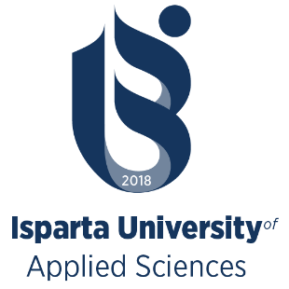
ISparta University OF  Applied Sciences | PARTNER INSTITUTION LOGO
[SIGNATURE & STAMP] | [SIGNATURE & STAMP]
Prof. Dr. Yılmaz ÇATAL (Rector) | LEGAL REPRESENTATIVE (TITLE, NAME, SURNAME)
Date, Place: _________________________ | Date, Place: __________________________

